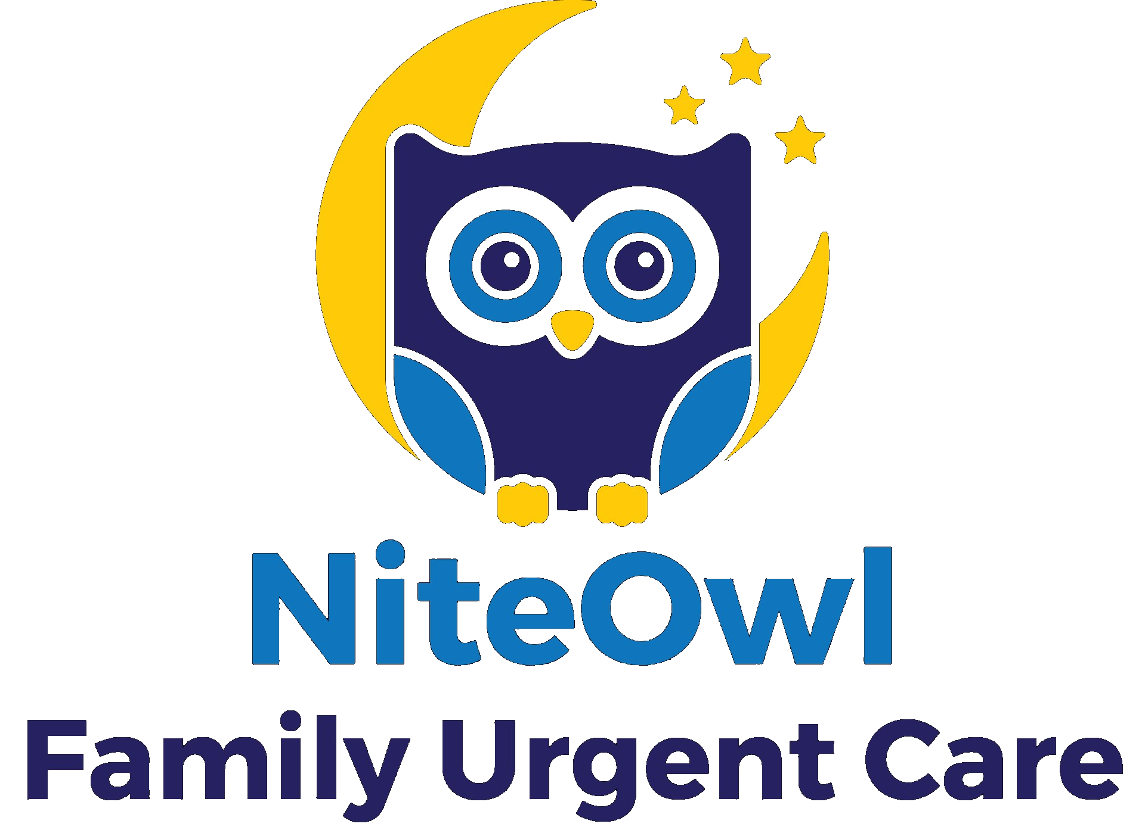
4687 University Drive, Collegedale, TN 37315 Phone: 423.648.6483 Fax: 423.206.2047 Collegedale@niteowlurgentcare.com

Medical Release Authorization
Patient Name (list any and all names used when attending SAU) | Birth Date | Southern ID
Phone Number | Year of most recent Southern attendance

I hereby authorize:
☐ NiteOwl Family Urgent Care at Southern Adventist University

☐ Name of Person/Organization:
Address: ________________________________________________________________________________________________________
________________________________________________________________________________________________________________
Phone: _______________ Fax: ______________ Email: __________________________ _________________

To release the below requested medical information to:
☐ NiteOwl Family Urgent Care Phone: 423.648.6483
4687 University Drive Fax: 423.206.2047
Collegedale, TN 37315 E-mail: Collegedale@niteowlurgentcare.com

☐ Name of Person/Organization: ________________________________________________________________________________________
Address: _______________________________________________________________________________________________________
_______________________________________________________________________________________
Phone: ________________ Fax: _____________ Email: ____________________________
For the following treatment dates: ☐ All dates of treatment ☐ For dates of treatment from ___ to ______________
Specific description of information to be disclosed:  ☐ Immunization/TB Screening records  ☐ All medical records for the time period indicated  ☐ Other (Specify):  The records are to be:  ☐ Faxed ☐ Mailed ☐ E-mailed ☐ Picked up | Individual authorization required for each of the following:  ☐ Mental Health Record ☐ AIDS/HIV  Signature: ______ Date: _____________
I understand that any information disclosed pursuant to this authorization may be subject to redisclosure by the recipient and may no longer be protected by federal privacy regulations. I understand that I may revoke this authorization in writing at any time by sending the revocation to the health care provider indicated above, unless the provider has already taken action in reliance on this authorization. Aside from this, I understand that upon expiration of the authorization, no further disclosure of the information may be made. I understand that a health care provider may decline to treat me if I refuse to sign this authorization only when the treatment is for the sole purpose of creating health information for disclosure to a third party. I further understand that the records to be released may contain or consist of information related to the following: contagious diseases (HIV/AIDS, TB, hepatitis, etc.), psychiatric treatment or psychotherapy.

__________________ __________________________________________________ _________________________________
Date | Signature of Patient (Parent/Legal Guardian if under age 18) | Relationship to Patient
This authorization expires 365 days from the date specified above or the date on which the requested release of information has been completed, whichever comes first. This release covers records of treatment only for the dates specified above. Fees/charges will comply with all laws and regulations applicable to release of information. This authorization can only be honored when all portions have been completed.

For Office Use Only:
☐ Faxed ☐ E-mailed ☐ Mailed ☐ Released to patient
Date: Sent by:

